It is the most basic statement among all conditional statements in Java. It evaluates a Boolean expression and allows the program to enter a block of code if the expression evaluates to true.

Syntax of if statement is as follows:

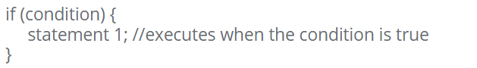

Example:

